1. :
   1. dbinom(100, 300, 1/3)

[1] 0.04881

* 1. pbinom(100, 300, 1/3)

[1] 0.5271

* 1. pdinom(99, 300, 1/3)

0.4783

* 1. 1-pbinom(109, 300, 1/3)

[1] 0.1228

* 1. pbinom(110, 300, 1/3)-pbinom(89, 300, 1/3)

[1] 0.8017

1. :
   1. Table

      Description automatically generated (Is this sorted for some reason?)

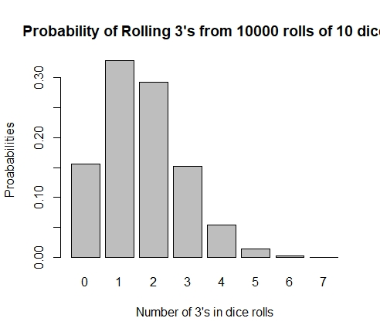

* 1. A screenshot of a computer

     Description automatically generated with low confidence

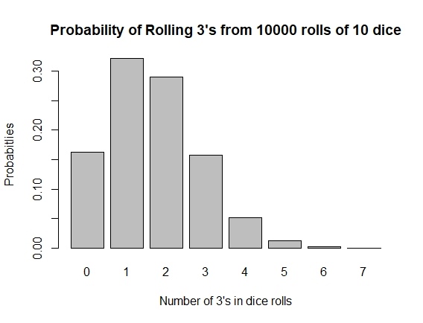

1. The 2 graphs are near identical. This is because in the we are trying to get the same thing but through slightly different methods (functions) to achieve it.

dbinom(0, 10, 1/6)

[1] 0.1615

dbinom(1, 10, 1/6)

[1] 0.323

dbinom(2, 10, 1/6)

[1] 0.2907

dbinom(3, 10, 1/6)

[1] 0.155

dbinom(4, 10, 1/6)

[1] 0.05427

dbinom(5, 10, 1/6)

[1] 0.01302

dbinom(6, 10, 1/6)

[1] 0.002171

dbinom(7, 10, 1/6)

[1] 0.0002481

All of these probabilities of getting a 3 are near identical to the probabilities on the graphs.